***Md. Naushad alam***

My works

**•** Computer operator

**•** Data entry

**•** Frontend Developer

**•** Microsoft word

**Languages:-**

**•** Hindi

**•** English

**Contact →**

**• Phone** – 7999586714

**• Email -** [alammdnaushad084@gmail.com](mailto:alammdnaushad084@gmail.com)

**• Skype -**

live:.cid.4da6abef0e2caaa8

**• *Address*** *- Balrampur Ramanujganj*

*Chhattishgarh 497220*

**Hobbies :-**

**•** Reading books. about programing

And Exited to learn how I can do

easily my work in short time.

**•** Running and workout .

**•** Video games in free time.

**•** Swimming.

**•** Walk in Natural places.



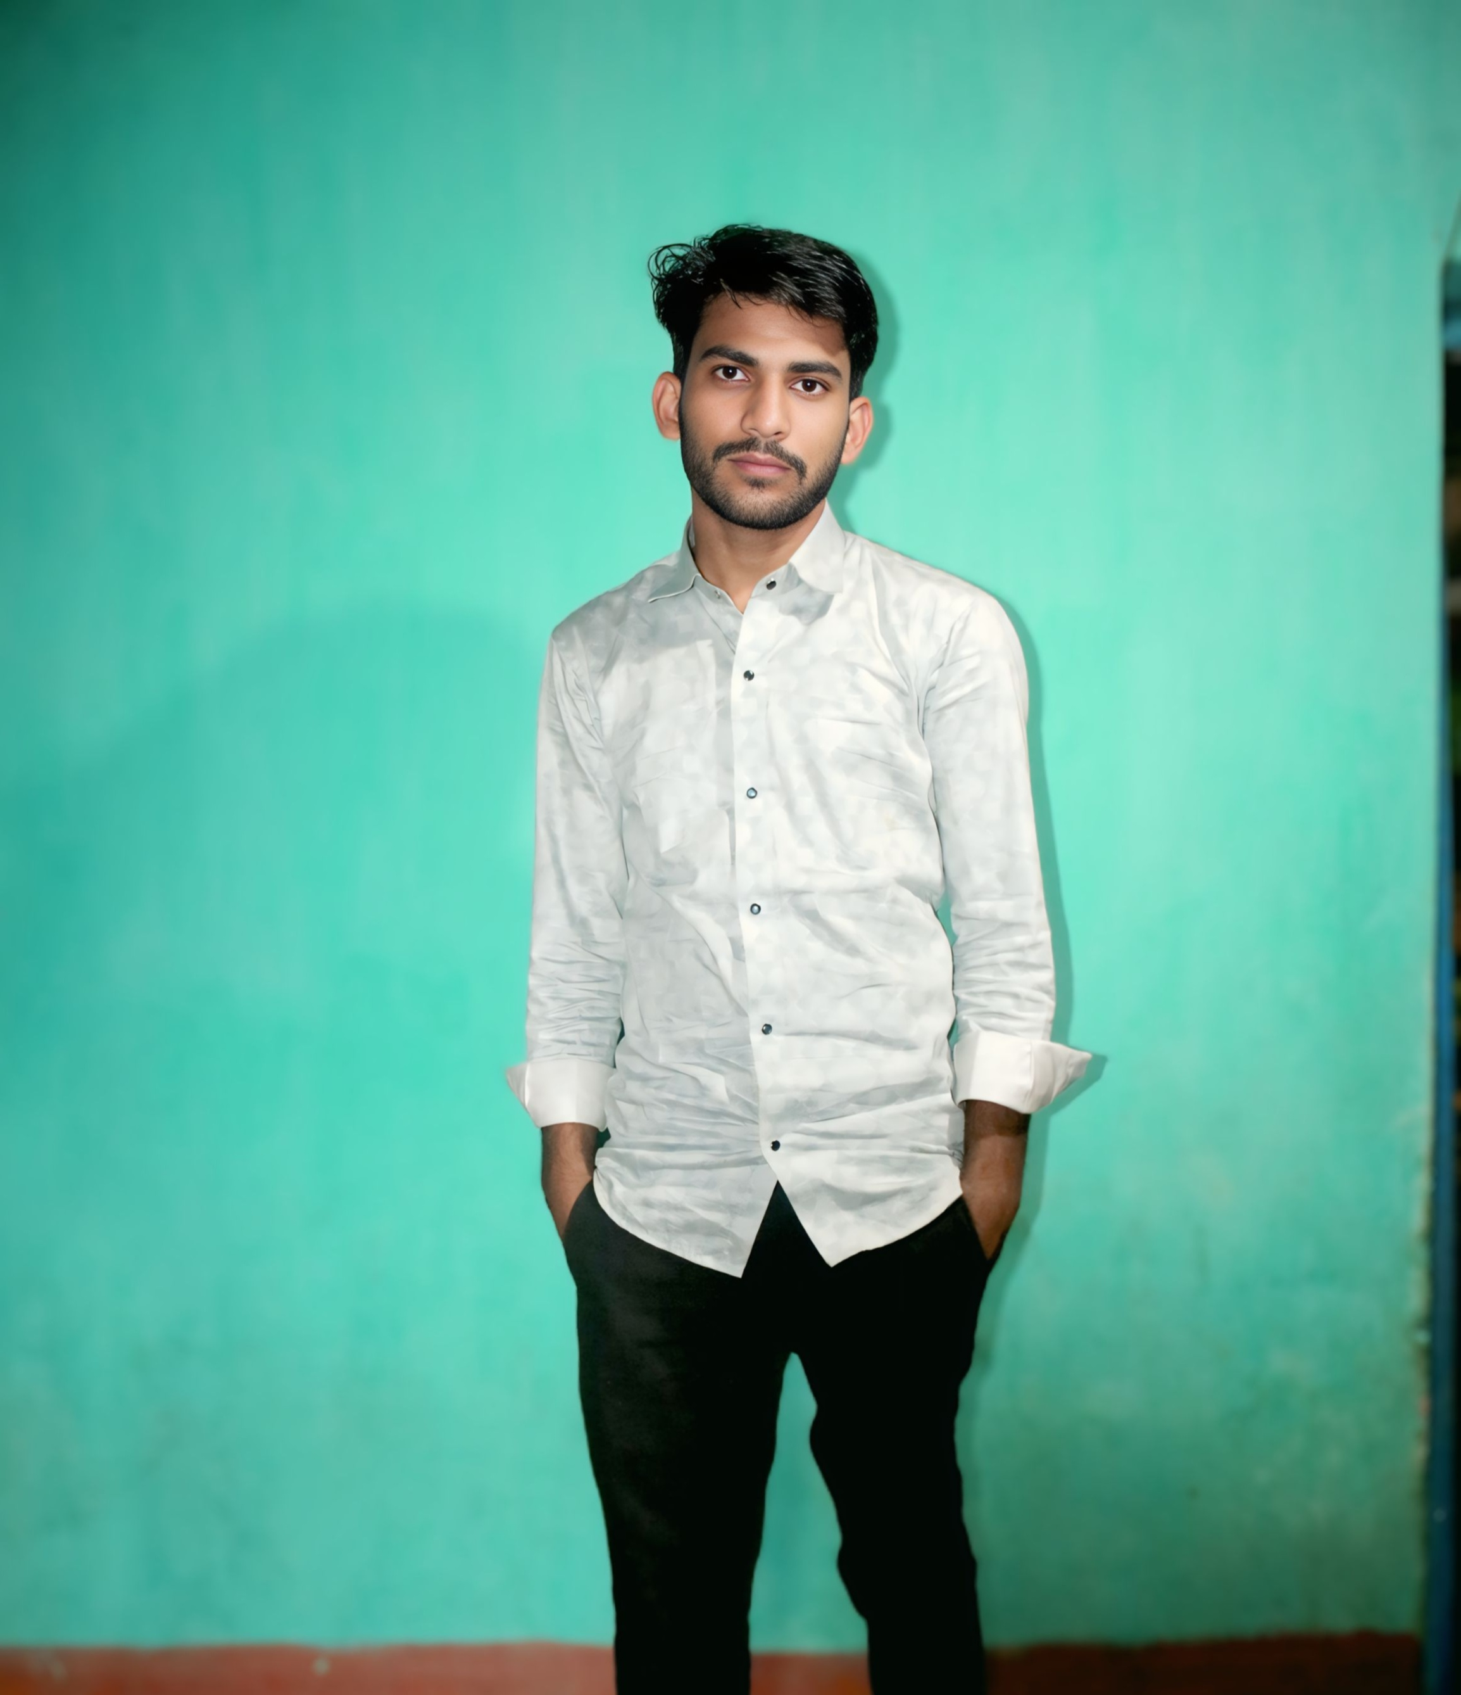

***MD. NAUSHAD ALAM (Edition)***

***FRONTEND DEVELOPER***

***Summary :-***

Computer Operator with a strong grasp of maintenance, and troubleshooting. Proficient in operating office software, managing files, and ensuring smooth system performance. Quick learner with excellent problem-solving skills and the ability to work efficiently.

***Education :-***

• **Govt. Higher secondary school**

Higher secondary / **Intermediate**

CBSE Board exam march 2023

• **Govt. college ramchandrapur**

Graduation from b.com

SGG university ambikapur Chattisgarh.

**Pursuing…..**

]

***Project :-***

* **Portfolio web.** (Html, Css & JavaScript)

A web to anyone can show my skill, work

experience and all about my education journey.

Visit : Naushadedition.com

* **Shoping web.** ( Html, Css & JavaScript)

A web were user visit to see the jewelry and that’s price also but can’t order

Visit: jewelrydekho.com

* **Multiple web clone** (Html, Css & JavaScript)

1. Jharkhand sukhad rahat 2.Resturant

Every site link prode in my portfolio site.

***Skill :-***

• Frontend Developer. • Microsoft word.

• Computer operator. • Data management.

• Consultation. • Fast learner. • Team work.